**GPS RECEIVER SCHEMATIC / BOARD**

1. **Generic Block Diagram**

Sistem gps tracker module menggunakan antena pasif sebagai penerima sinyal dan meneruskan ke perangkat gps display.

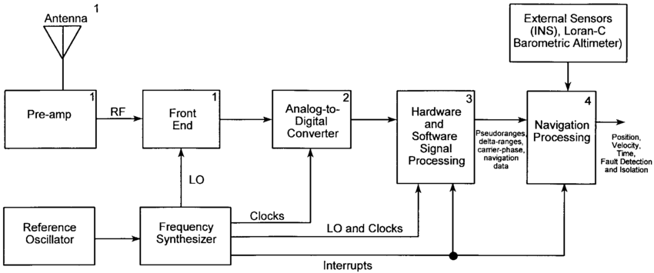

**Gambar 1. Generic GPS Block Diagram**

1. **Passive Antenna Module**

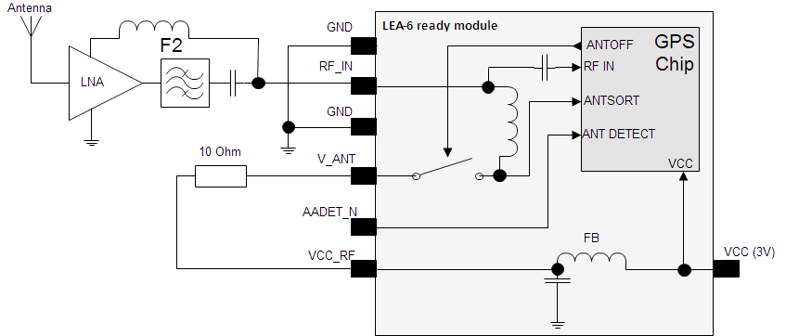

**Gambar 2. Antena gps pasif menggunakan modul LEA-6**

1. **Passive Chipset**

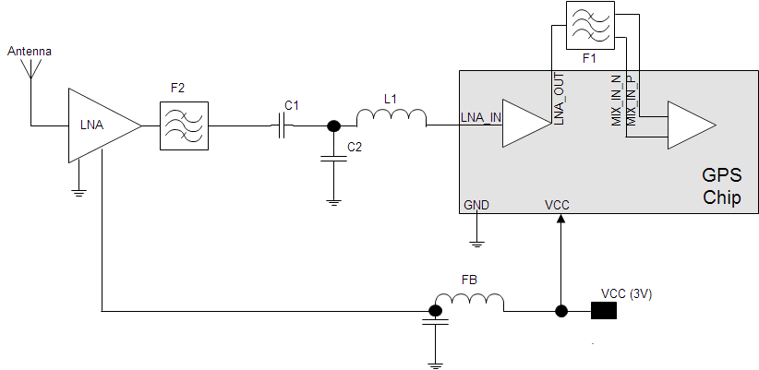

**Gambar 3. Standard LNA chipset dengan antena pasif**

1. **Board**

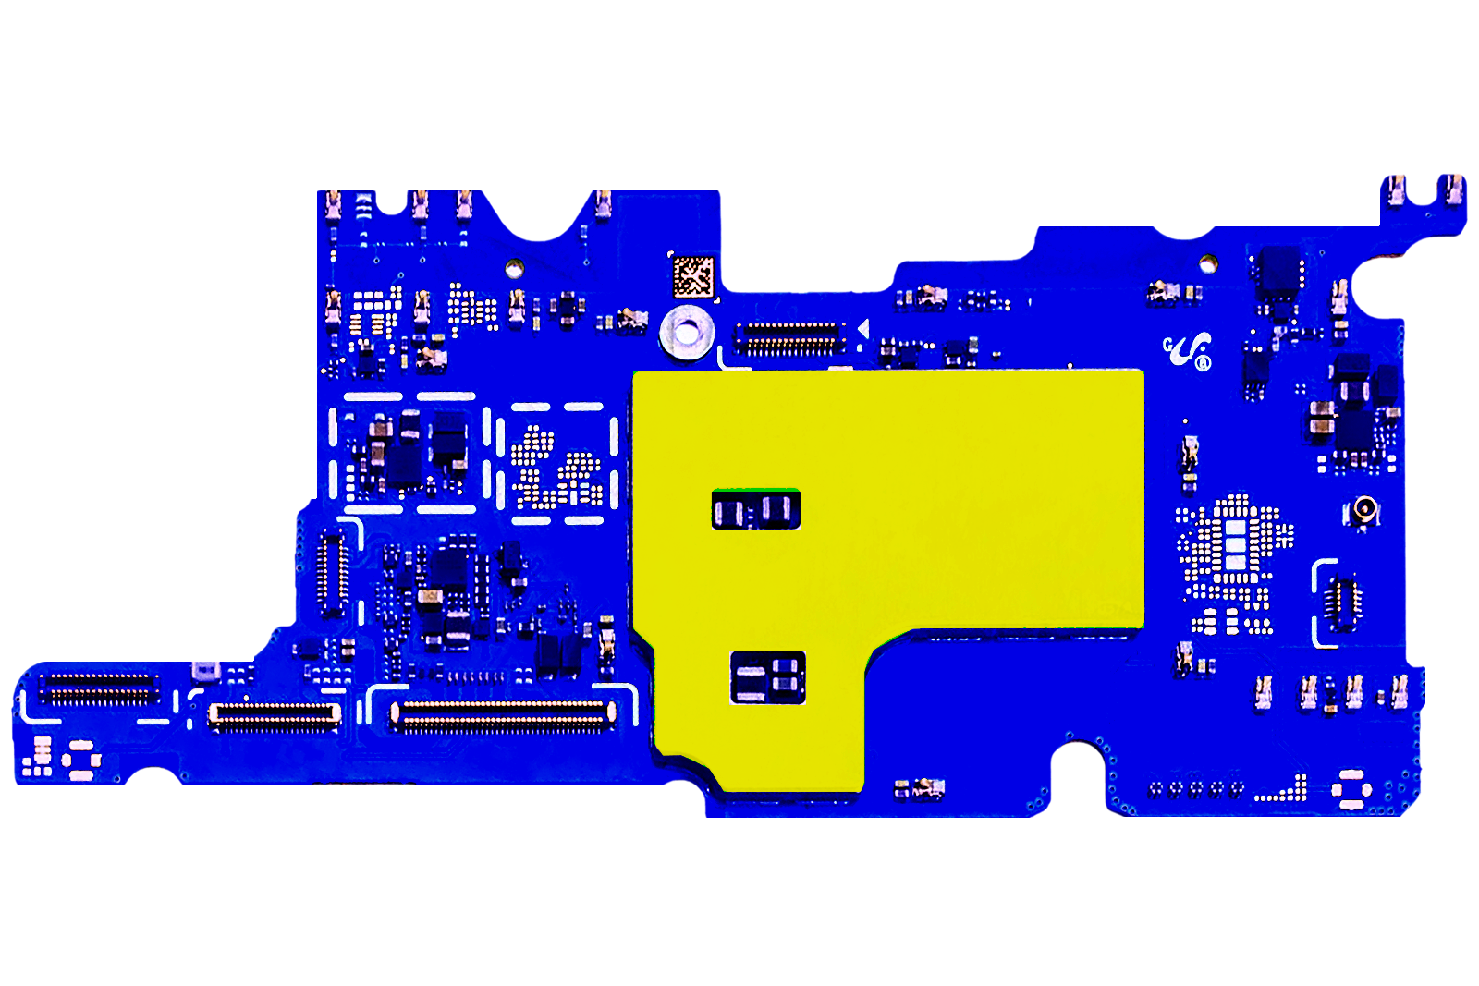

DISPLAY OUT

CORE APPLICATION PROCESSOR

**Gambar 4. GPS Motherboard Side-A design drawing**

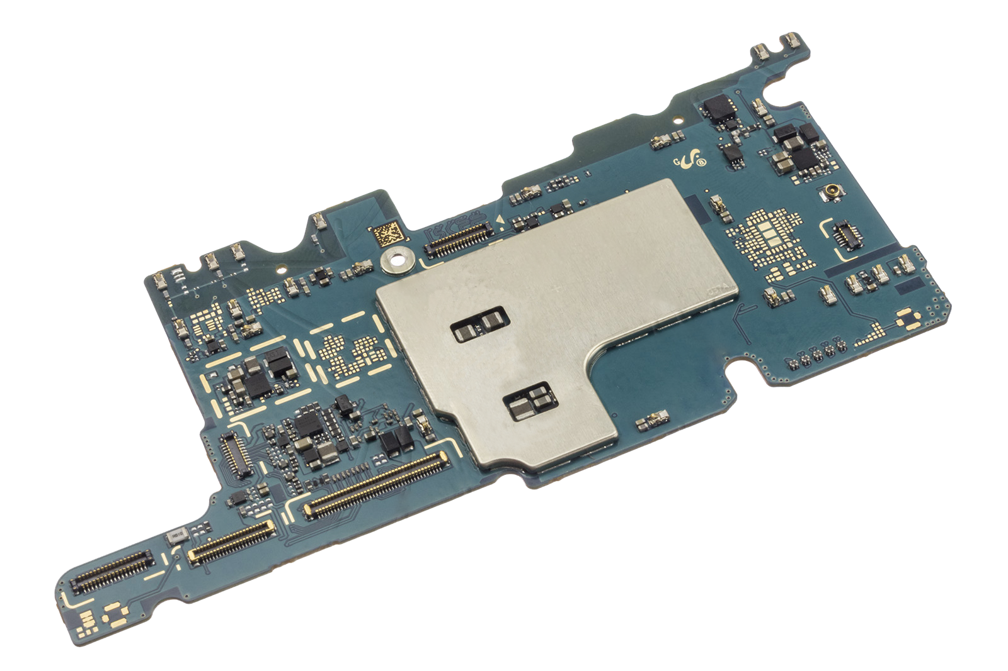

**Gambar 5. GPS Motherboard Side-A**

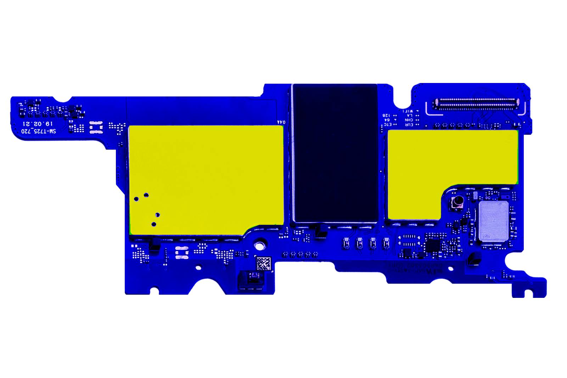

PROCESSOR / POWER MANAGEMENT

MULTICHIP MEMORY, MOBILE DDR SDRAM, MEMORY CONTROLLER

BATTERY MANAGEMENT SYSTEM

COMPASS ACCELEROMETER

GPS RECEIVER

**Gambar 7. GPS Motherboard Side-B design drawing**

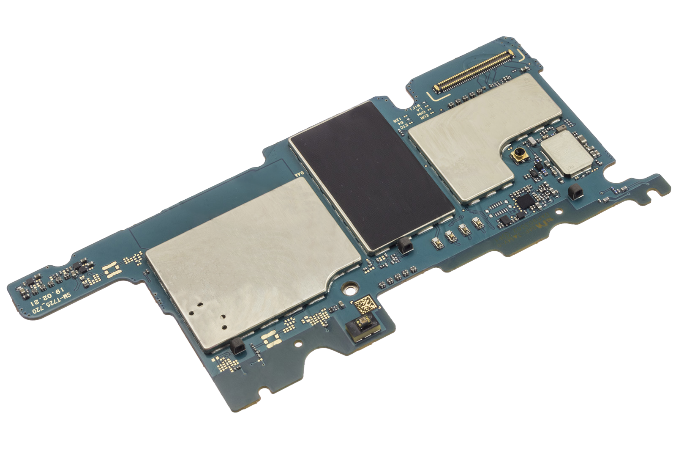

**Gambar 6. GPS Motherboard Side-B**